Person affected (or their manager):
- Immediately: Report immediately (by phone) any Notifiable Event or where there was potential for notifiable event by phone to your Manager and to the Director Safety, Health and Wellbeing.
- Within 24 hours of incident - please download and fill in the Section A and then scan and send to hsw@aut.ac.nz (Health and Safety admin) and to your Manager, Supervisor Or Lecturer.
- Within 2 weeks after the incident - Manager, Supervisor Or Lecturer fill in Section B and return whole form to hsw@aut.ac.nz (Health and Safety admin).
- Keep copies of this form with the Faculty/Division & the employee.

Section A
REPORTING PERSON’S DETAILS
PRINT Name: | Date of birth: | Sex:
Position: | Faculty / School or Department or Contractor:
Contact phone: | Email:
Reporting person’s Manager / Supervisor / Lecturer

PRINT Name: …………………………………………………………………………………………….. Phone: ………………………………………………

EVENT DETAILS & QUICK FIX
Date of event:…………………………… Time of Event…………………………………..

Place of event: (Room # or Location) ..………………………………………………………………………………………………………………………….

Campus Site or Address: ...................………………………………………………………………………………………………………………….…………
In a SENTENCE describe the Incident using the format of the incident, subject and the consequence.
[ For example only - A slip (incident) by a student (subject) resulting in a twisting ankle (consequence) ]

…………………………………………………………………………………………………………………………………………………………………………………..

…………………………………………………………………………………………………………………………………………………………………………………..

WITNESS DETAILS (IF ANY)

NAME: ….…………………………………………………………………………………………..…………………… PHONE ………………………….

NAME: ………………………………………………………………………………………………..…………………… PHONE ………………………….

QUICK FIXES: ……………………………………………………………………………………………………………………………………………………….

…………………………………………………………………………………………………………………………………………………………………………………

…………………………………………………………………………………………………………………………………………………………………………………

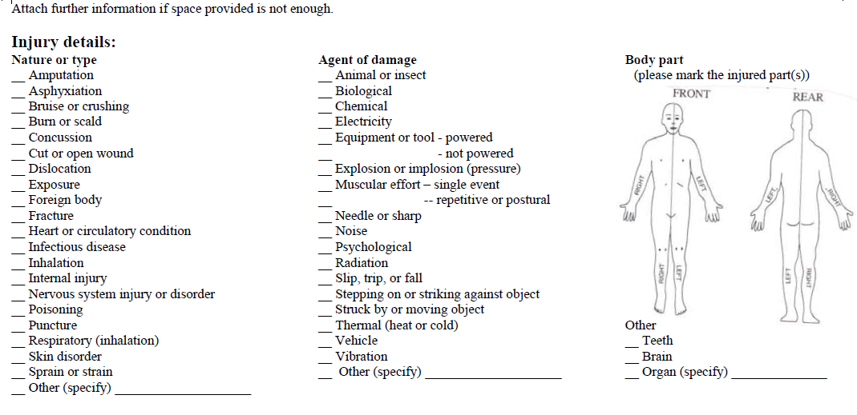
Mark the injury details: (if applicable)

Section B – Managers / Supervisors / Lecturers
INCIDENT IS INVESTIGATED. ROOT CAUSES ARE ESTABLISHED AND CORRECTIVE ACTION IDENTIFIED?

YES INCOMPLETE, estimated completion date is: ……………………………….

THIS WAS A NOTIFIABLE EVENT (See AUTi HSW webpage on how to report an incident)

YES NO

This incident harmed (tick multiple boxes if necessary)

Single Person Multiple People No-one Environment Building or Vehicle

THE OUTCOME FOR THE INJURED PERSON(S) WAS:

Lost Time Day(s) Off Work Multiple Persons with different Outcomes

Medical treatment by a Health
professional (GP, Hospital, Ambulance) No Treatment or First Aid

Restricted Work (NO lost time, person given light duties or alternative work whilst rehabilitating)
Person requires a return to work rehabilitation plan?

Signature name and date of supervisor:

Signature name and date of Head of School or Section:

